**Product Demand Prediction with Machine Learning**

You must have studied that the demand for a product varies with the change in its price. If you take real-world examples, you will see if the product is not a necessity, then its demand decreases with the increase in its price and the demand increases with the decrease in its price. If you want to know how we can predict demand for a product with machine learning, this article is for you. In this project, I will walk you through the task of product demand prediction with machine learning using Python.

A product company plans to offer discounts on its product during the upcoming holiday season. The company wants to find the price at which its product can be a better deal compared to its competitors. For this task, the company provided a dataset of past changes in sales based on price changes. You need to train a model that can predict the demand for the product in the market with different price segments.

The dataset that we have for this task contains data about:

1. the product id;
2. store id;
3. total price at which product was sold;
4. base price at which product was sold;
5. Units sold (quantity demanded);

I hope you now understand what kind of problem statements you will get for the product demand prediction task. In the section below, I will walk you through predicting product demand with machine learning using Python. Let’s start by importing the necessary Python libraries and the dataset we need for the task of product demand prediction:

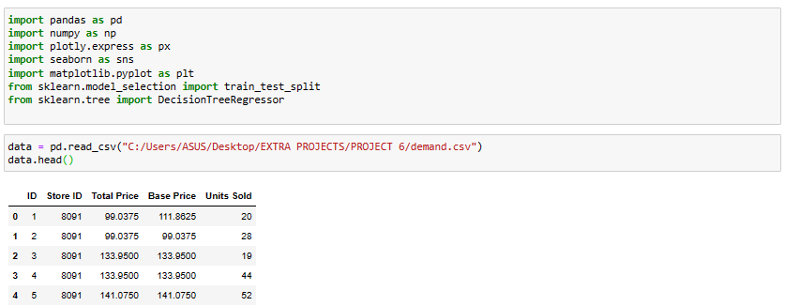

Fig 1

Now let’s have a look at whether this dataset contains any null values or not:

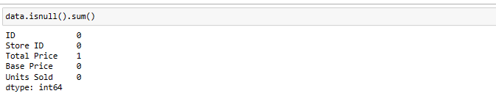

Fig 2

So the dataset has only one missing value in the **Total Price** column, I will remove that entire row for now:



Fig 3

Let us now analyse the relationship between the price and the demand for the product. Here I will use a scatter plot to see how the demand for the product varies with the price change:

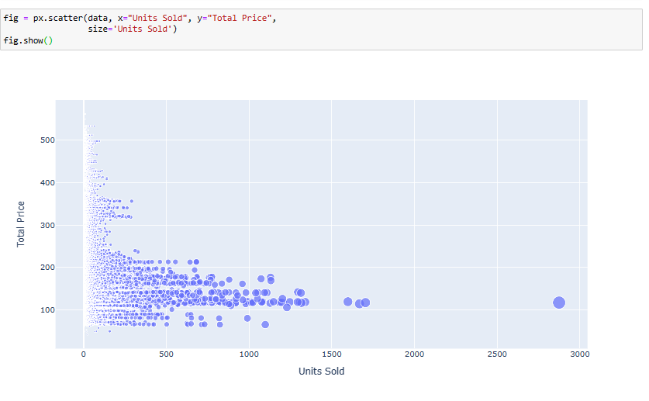

Fig 4

We can see that most of the data points show the sales of the product is increasing as the price is decreasing with some exceptions. Now let’s have a look at the correlation between the features of the dataset:

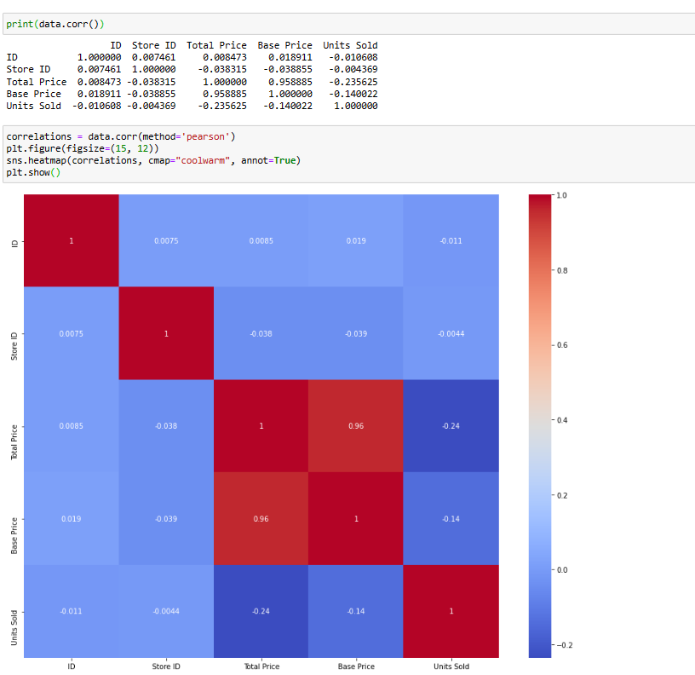

Fig 5

Now let’s move to the task of training a machine learning model to predict the demand for the product at different prices. I will choose the **Total Price** and the **Base Price** column as the features to train the model, and the **Units Sold** column as labels for the model:



Fig 6

Now let’s split the data into training and test sets and use the decision tree regression algorithm to train our model:

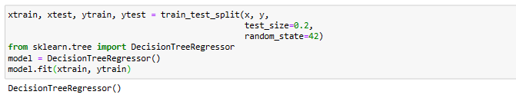

Fig 7

Now let’s input the features **(Total Price, Base Price)** into the model and predict how much quantity can be demanded based on those values:

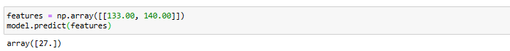

Fig 8

### **Summary**

So this is how you can train a machine learning model for the task of product demand prediction using Python. Price is one of the major factors that affect the demand for the product. If a product is not a necessity, only a few people buy the product even if the price increases. I hope you liked this article on product demand prediction with machine learning using Python